1. Identify the parts of the computer. If there are multiple items of the same type, you need to give only ONE answer.

___7__ Power Connector

___1__ CPU Socket

_____ Parallel Port

__31___South Bridge

___32__PS2 Port

30___ North Bridge

_22__ PCI Slot

3,4,5,6 Memory Slot

__35_ Ethernet Port

_23__ Graphics Card Slot

_33__ USB Ports

_8__ Battery

__36_ Audio Ports

9,12,13,16 SATA connector

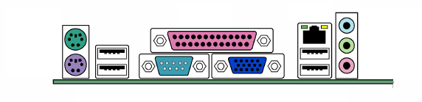

32

33

34

35

36

37

38

30

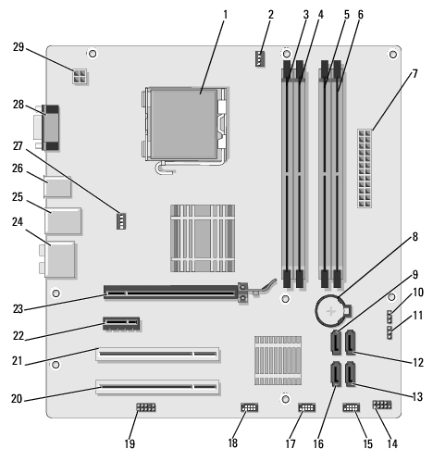

31

1. Explain what an algorithm is? [K 2]

An algorithm is a process/ set of rule to follow to perform calculations or to solve a usually mathematical problem.

1. Name two devices that provide long term storage of data. [K 2]

Two devices that provide long term data storage include Hard drives and tapes.

1. Name one example of application software. [K 1]

An example of application software could be Microsoft Word.

1. The hardware of a computer has many parts, but they fall into one of four general categories – processor, memory, input and output (I/O) devices. Describe the function of each category.

[K 4]

1. Processor:

They are used to process information and carry out instructions.

1. Memory:

The function of memory is to store data.

1. Input devices:

The function of input devices is to give a person a way to control a computer/ computer software.

1. Output devices:

The function of output devices is to provide the user with a means of knowing what is happening on the computer.

1. In terms of size and speed of communication, describe the differences of Main Memory, Hard Drive Storage and Cache Memory.

Regular Size Large Size Regular Speed

Small Size Slow Speed Fast Speed

|  |  |  |
| --- | --- | --- |
|  | Relative Size | Relative Speed |
| Main Memory | Regular Size | Regular Speed |
| Hard Drive Memory | Large Size | Slow Speed |
| Cache Memory | Small Size | High Speed |

1. Name 3 input devices and 3 output devices

|  |  |
| --- | --- |
| Input | Output |
|  | 1. |
| 2. | 2. |
| 3. | 3. |

1. State the 4 basic functions of a computer

1. 3.

2. 4.

1. *Briefly* explain each of the following in terms of computer hardware
2. CPU
3. RAM
4. Computer BUS
5. Hard Drive
6. BIOS Battery
7. Software Development Cycle – Matching

|  |  |  |  |
| --- | --- | --- | --- |
| *Design the Algorithm* | *Implementation / Writing Code* | *Define & Analyze the Problem* | *Maintenance* |
| *Testing* |  |  |  |

Step 1 ________________

Stablish an overview of the intended software project by the people who requested it. The specific needs and functions of the intended software application are also defined. An examination and study of the end-user information needs are completed.

Step 2 ________________

This step describes the desired features and operations in detail, including flow charts, screen layouts, calculations, formulas, process diagrams, pseudo code, and other documentation.

Step 3 ________________

The computer programming code is written during this step.

Step 4 ________________

Testing brings together all of the pieces of the software into a testing situation that checks for errors, bugs, and correct functionality.

Step 5 ________________

This is the final step of initial development where the software is put into use. It is run and used by the people who requested it. During the rest of the software's life, there needs to be changes, corrections, and additions. This step is an ongoing process that occurs for many, many years, as long as the software is kept in use.